𝗥𝗲𝘁𝗿𝗶𝗲𝘃𝗮𝗹 𝗘𝗻𝗴𝗶𝗻𝗲𝗲𝗿𝗶𝗻𝗴
Building a RAG pipeline in 2026 requires far more engineering than just doing:
𝗣𝗗𝗙 → 𝗘𝗺𝗯𝗲𝗱𝗱𝗶𝗻𝗴𝘀 → 𝗖𝗵𝗿𝗼𝗺𝗮𝗗𝗕 → 𝗚𝗣𝗧
Modern production RAG systems are evolving into 𝗿𝗲𝘁𝗿𝗶𝗲𝘃𝗮𝗹 𝗶𝗻𝘁𝗲𝗹𝗹𝗶𝗴𝗲𝗻𝗰𝗲 𝗽𝗶𝗽𝗲𝗹𝗶𝗻𝗲𝘀.
Today’s enterprise-grade flow looks more like:
𝗗𝗼𝗰𝘂𝗺𝗲𝗻𝘁𝘀 → 𝗦𝘁𝗿𝘂𝗰𝘁𝘂𝗿𝗲-𝗮𝘄𝗮𝗿𝗲 𝗽𝗮𝗿𝘀𝗶𝗻𝗴 → 𝗦𝗲𝗺𝗮𝗻𝘁𝗶𝗰/𝗛𝘆𝗯𝗿𝗶𝗱 𝗰𝗵𝘂𝗻𝗸𝗶𝗻𝗴 → 𝗠𝗲𝘁𝗮𝗱𝗮𝘁𝗮 𝗲𝗻𝗿𝗶𝗰𝗵𝗺𝗲𝗻𝘁 → 𝗛𝘆𝗯𝗿𝗶𝗱 𝗿𝗲𝘁𝗿𝗶𝗲𝘃𝗮𝗹 → 𝗥𝗲𝗿𝗮𝗻𝗸𝗶𝗻𝗴 → 𝗖𝗼𝗻𝘁𝗲𝘅𝘁 𝗰𝗼𝗺𝗽𝗿𝗲𝘀𝘀𝗶𝗼𝗻 → 𝗟𝗟𝗠
Modern systems don’t just store raw text chunks anymore.
They store retrieval intelligence.
Example:
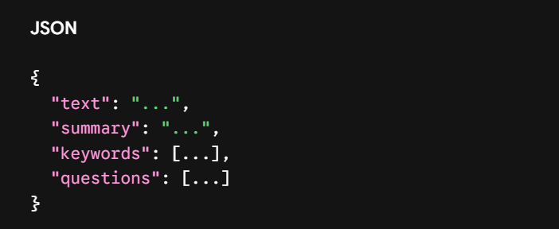

𝗦𝘆𝗻𝘁𝗵𝗲𝘁𝗶𝗰 𝗾𝘂𝗲𝘀𝘁𝗶𝗼𝗻𝘀 𝗲𝘀𝗽𝗲𝗰𝗶𝗮𝗹𝗹𝘆 𝗮𝗿𝗲 𝗳𝗮𝘀𝗰𝗶𝗻𝗮𝘁𝗶𝗻𝗴.
Why? Because users search using questions: “What caused revenue growth?”
But chunks are written as statements: “Revenue increased due to Southeast Asia expansion.”
That mismatch is where a lot of retrieval systems silently fail.
The industry is slowly realizing: Better prompts cannot fix bad retrieval.
And honestly… learning about:
- Docling
- HybridChunker
- Contextual retrieval
- Rerankers
- ChromaDB internals
- Query-document alignment
...changed how I think about AI backend engineering.
#AI #RAG #LLM #GenAI #AIEngineering #MachineLearning #ChromaDB #LangChain #MLOps

Example:

- Document: Lets say a pdf with below content
=================================
SECTION 1: PAYMENT RULES
=================================
Suppliers must submit invoices within 7 days.
Late submissions require manager approval.
---------------------------------
TABLE:
Supplier | Lead Time | Escalation
ABC | 14 days | Level 2
XYZ | 21 days | Level 3
---------------------------------

=================================
SECTION 2: PENALTIES
=================================
Repeated delays may reduce supplier score.

- 𝗦𝘁𝗿𝘂𝗰𝘁𝘂𝗿𝗲-𝗮𝘄𝗮𝗿𝗲 𝗽𝗮𝗿𝘀𝗶𝗻𝗴: Using Docling, Internally Docling roughly creates something LIKE from the Input Pdf:
doc = {
sections: [
{
heading: "SECTION 1: PAYMENT RULES",

content: [
paragraph_1,
paragraph_2,
table_1
]
},

{
heading: "SECTION 2: PENALTIES",

content: [
paragraph_3
]
}
]
}

- 𝗦𝗲𝗺𝗮𝗻𝘁𝗶𝗰/𝗛𝘆𝗯𝗿𝗶𝗱 𝗰𝗵𝘂𝗻𝗸𝗶𝗻𝗴:
Think of HybridChunker as: intelligent packaging system, Its job:
Take structured document
↓
Create meaningful AI-friendly pieces

WHAT IS CHUNK?
A chunk is basically: small meaningful unit of knowledge
Example:
BAD chunk:
"...supplier score SECTION 2 penalties..."
Meaning broken.
GOOD chunk:
Section: Penalties
Repeated delays may reduce supplier score.

VISUALIZATION OF WHAT HAPPENS:

STEP 1 — Chunker Reads Structure
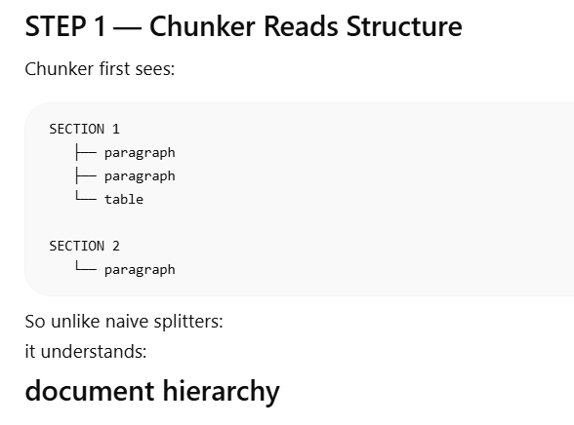
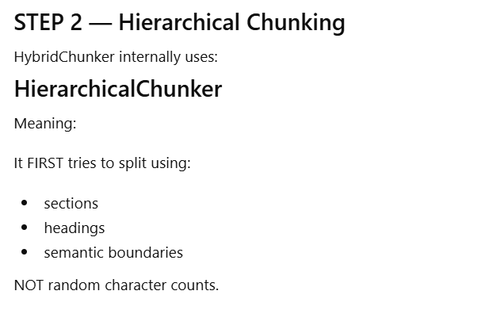

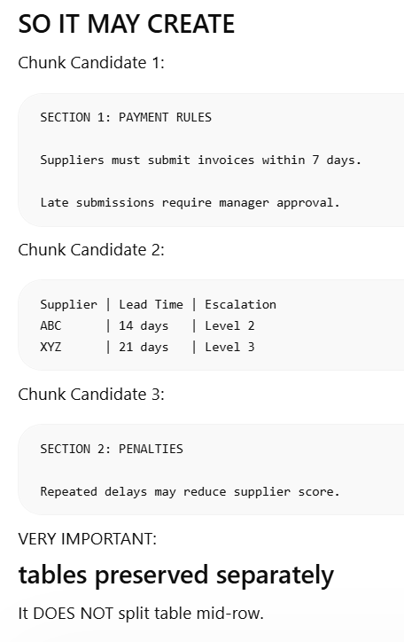

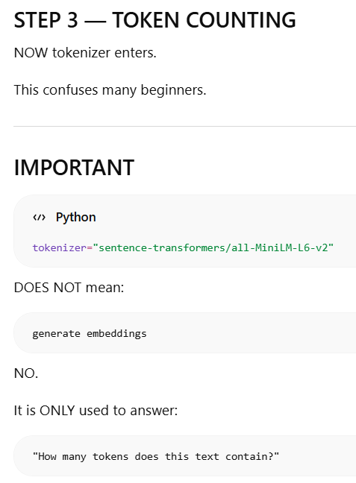
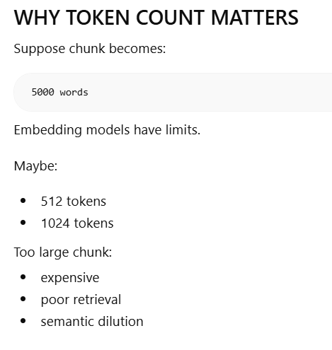
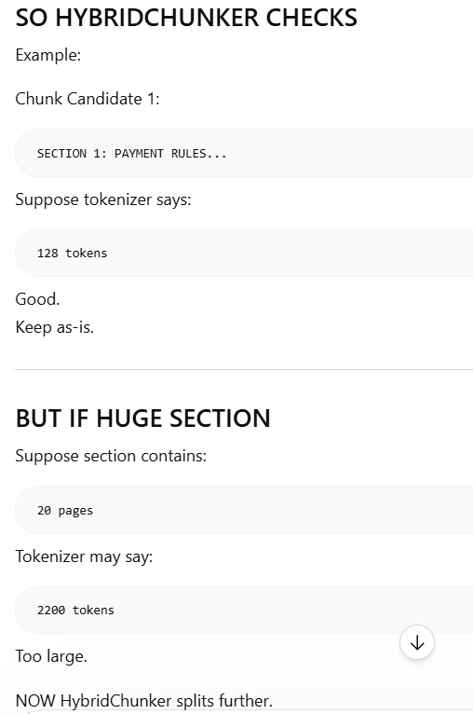

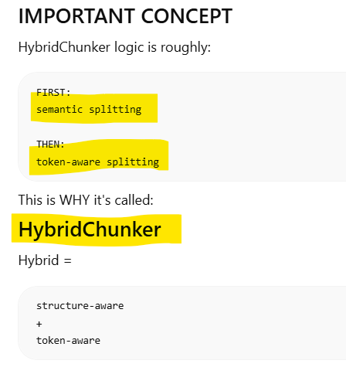
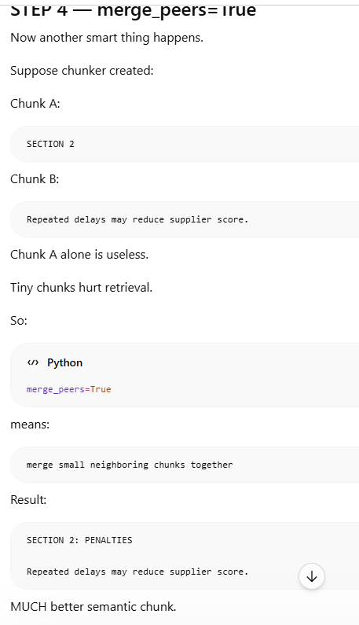
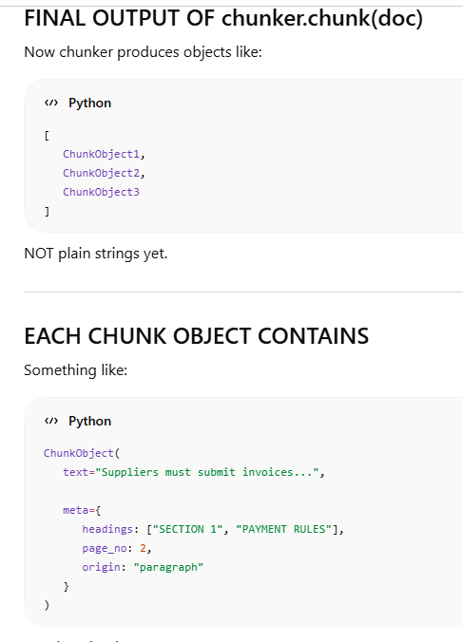
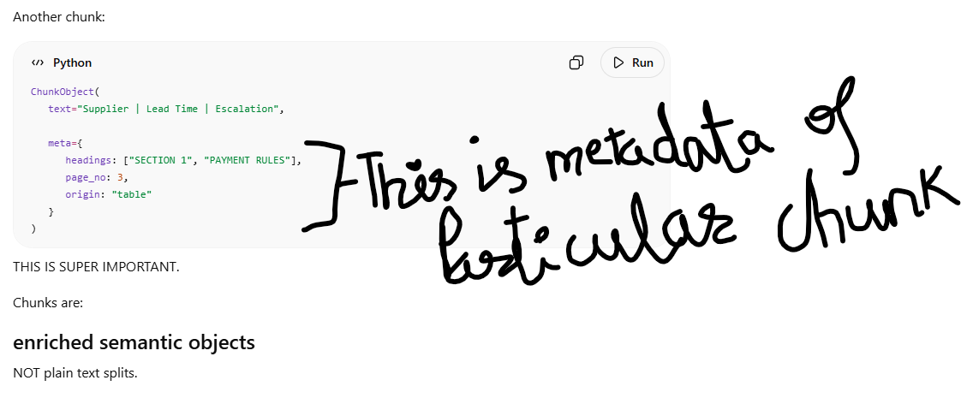
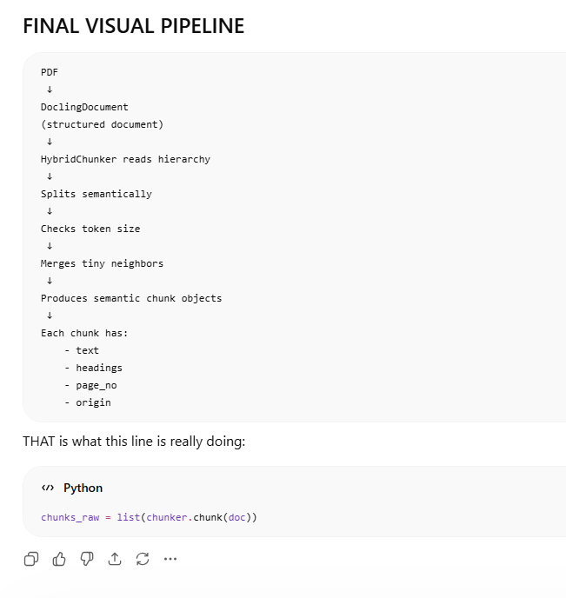

- Metadata Enrichment

Currently ,
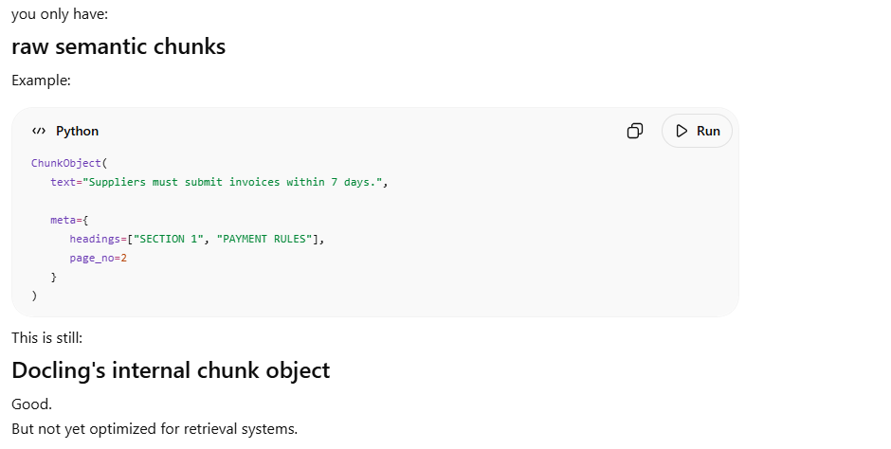

Next, we will enrich the chunk with:
- business metadata
- retrieval metadata
- filtering metadata
- debugging metadata
This is why it's called: Metadata Enrichment

BEFORE ENRICHMENT
Chunk looks like:
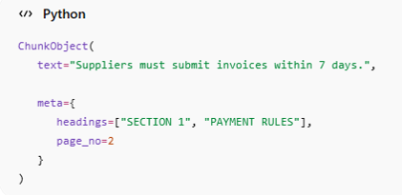
After Enrichment:
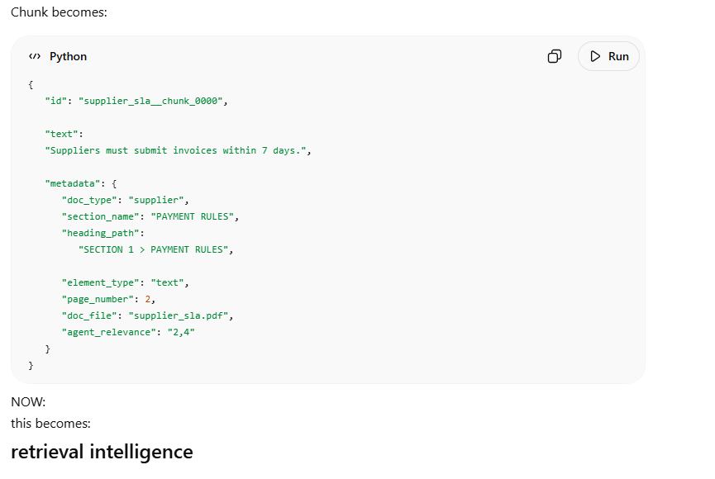
** Note in chunk summary can be added ["metadata"] ["chunk_summary"] = _summarise_chunk(c["text"], c["metadata"]["element_type"])
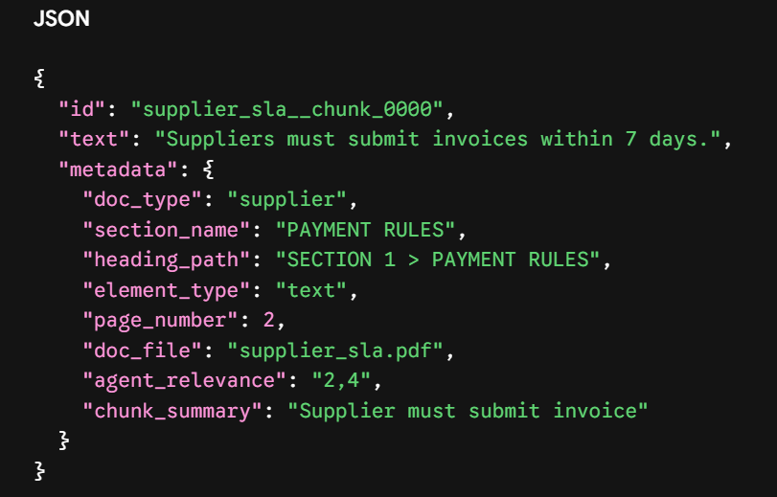
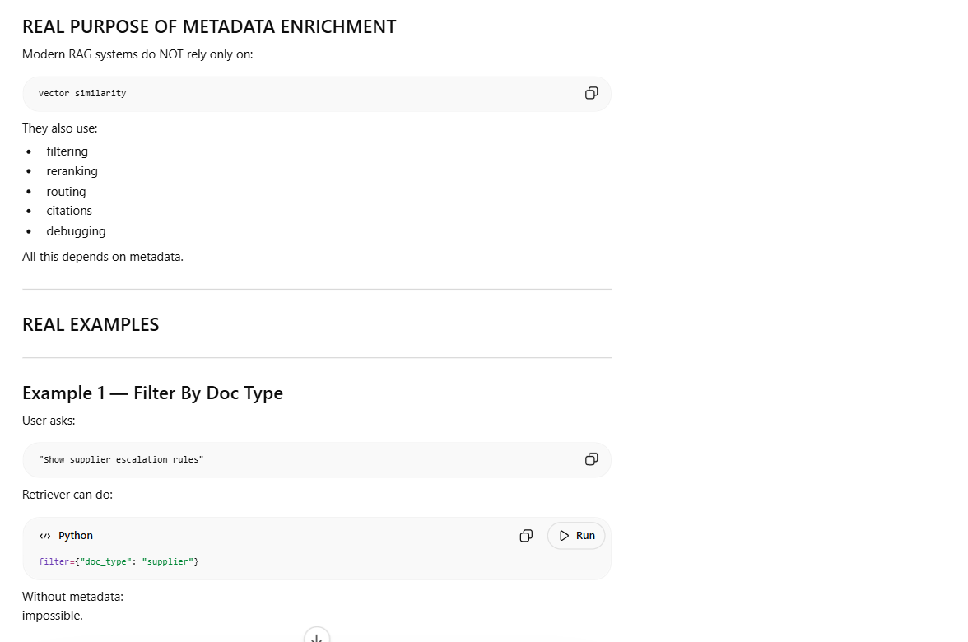
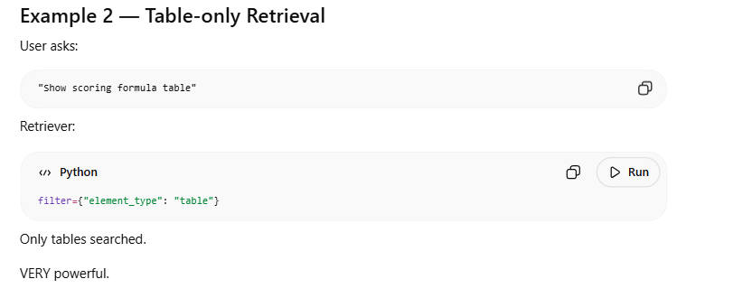
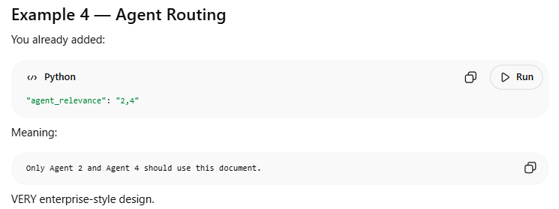

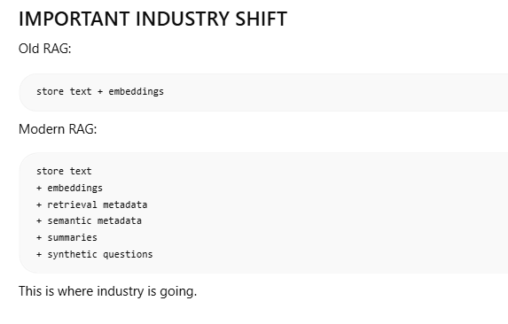
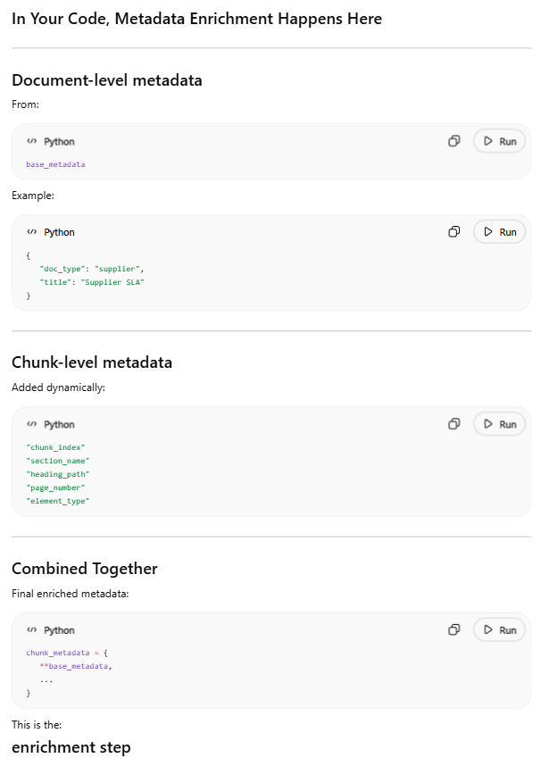
- Vector DB insertion
We having chunks now in human readable format


We will store it in vector db collection. Think of collection like: SQL Table BUT for vectors.
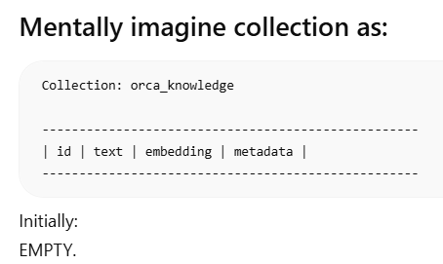

By using these lines of code:
collection.add(
Ids = [c["id"] for c in new_chunks],
documents= [c["text"] for c in new_chunks],
metadatas = [c["metadata"] for c in new_chunks],
)

So we pass id, text (as document ) and metadata. Chroma internally does for the text, embedding generation.
document text
↓
embedding model
↓
vector generated
↓
store everything together

